Trump and China Share a Bad Idea on Trade

Imports are things we want, and we pay for them with exports. Isn’t getting more for less a good thing?

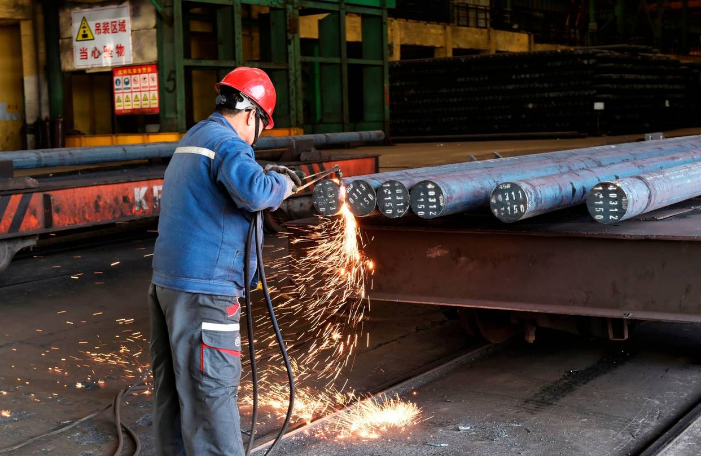
A worker cuts steel at a factory in Zouping, China, April 9. PHOTO: AFP/GETTY IMAGES
By
Robert J. Barro
April 10, 2018 6:23 p.m. ET

The Trump theory of international trade seems straightforward: Selling stuff to foreigners is good, and buying stuff from foreigners is bad. It’s a form of mercantilism. Exports are attractive because they represent domestic production and American jobs. Imports are undesirable because that production and employment otherwise could have happened at home.
Simple economic reasoning, however, suggests that this logic is backward. Imports are things we want, whether consumer goods, raw materials or intermediate goods. Exports are the price we have to pay to get the imports. It would be great, in fact, if we could get more imports without having to pay for them through added exports.
Economists typically favor free trade, which has a lot to recommend it from a global perspective. As my favorite economist, David Ricardo, argued in the early 1800s, free trade ensures that production takes place in its most efficient location, as governed by principles of comparative advantage. That’s why the U.S. imports bananas and exports soybeans and high-tech products.
Nevertheless, departures from free trade can sometimes be rewarding for a single country. For example, if the Chinese want to subsidize particular goods, Americans can benefit by buying them at artificially low prices. In the extreme case of China giving goods away free, it takes a lot of imagination to construct a model in which this “dumping” would be bad for the U.S. overall (though it might harm some American producers).
President Trump and Commerce Secretary Wilbur Ross have argued recently that the Trump theory implies a trade war can be desirable if directed against a country, such as China, with which the U.S. has a large trade deficit. In 2017, the Chinese sold the U.S. $524 billion of goods and services and bought only $187 billion, for a bilateral trade deficit of $337 billion.
As I understand the reasoning, it’s that China has more to lose. If a full-blown trade war cut bilateral trade to zero, the U.S. would lose just $187 billion in sales to Chinese customers, while China would lose $524 billion in sales to Americans. In reality, both countries would be hurt in a trade war, and the U.S. would probably lose more by being cut off from Chinese imports.
The twist is that China’s leaders seem to embrace the same mercantilist theory of international trade that Mr. Trump espouses. They probably agree that they have been taking the U.S. to the cleaners for years by selling Americans far more goods and services than they buy. This outlook is actually favorable for avoiding a trade war, since it makes the Chinese more likely to offer serious concessions, including the removal of restrictions on American imports and investment.
Many serious commentators look at America’s large trade deficit with China and argue that something has to be done. But it’s misleading to look at a single bilateral trade deficit, given that the U.S. also runs many bilateral trade surpluses. To the extent that trade deficits are a legitimate economic concern, the question is the global trade deficit, which totaled $568 billion in 2017. The worry is that this overall deficit has led to a large U.S. debt to foreigners, which must be repaid eventually. At the end of 2017, this debt stood at an impressive $7.8 trillion, or 40% of U.S. gross domestic product.
Theoretically, the large U.S. debt should result in an excess of money that Americans pay out to foreigners compared with what Americans get from foreigners. This imbalance should reduce U.S. imports, thereby moving the economy toward balanced trade overall. But things have not worked out this way. Instead the net investment income America earns from abroad has grown over time, reaching $251 billion, or 1.3% of GDP, in 2017. An explanation for part of this puzzling pattern is that the U.S. borrows a lot through low-interest Treasury paper and then earns much higher returns on direct investments and portfolio holdings. Somehow, America’s low-interest government debt is highly valued by the rest of the world, which allows the persistent gap between imports and exports to continue. As Jason Furman, chairman of President Obama’s Council of Economic Advisers, put it to me recently, the U.S. economy is now the world’s largest and most successful hedge fund.
If President Trump won’t believe economists who tell him that a trade war is ill-advised, he should at least believe the stock market. Since his election, Mr. Trump has pointed with pride to rising share prices, which he has attributed to his sound policies on taxes and regulations. Although there is a danger of reading too much into day-to-day fluctuations, it is probably true that stock prices have no equal as a report card on economic policy. Thus Mr. Trump is right that the stock-market advance signals support for his pro-market agenda. He should take it seriously, then, when talk of tariffs and trade wars leads to sell-offs and persistently high volatility. These are signs, if only the president will heed them, that the new Trump mercantilism is not such a good idea.
Mr. Barro is a professor of economics at Harvard University and a visiting scholar at American Enterprise Institute.

